Valuation of Payment Industry, Financial Services

**MasterCard, VISA, PayPal, American Express**

Financial Statement information as of 12/31/2019

Stock Information as of 04/04/2020

***Prepared by:***

Carlo Masera

**Valuation Objective and Summary**

The objective of this valuation is to take a broad view of the leading companies of the financial service industry by closely analyzing four stocks. These include *Visa, MasterCard, American Express* and PayPal. More specifically, such companies offer credit cards and payment systems as their core products and services.

The valuation approach is extensive, but at its essence focuses on four major factors:

1. **Financial Reports**
2. **Ratios & Multiples**, **over time**
3. **Stock Price Movement Analysis**
4. **Portfolio Analysis**
5. **Earnings Forecasting (DCF Model)**

**Sources of Information**

The data used throughout this analysis is external. Financial statements are collected from the *Securities and Exchange Commission*, through its **EDGAR** online public database. Information relative to the stock is gathered from *Yahoo! Finance* through an application programming interface (API).

Table of Contents

Section 1 4

Economic Overview 4

General Economic Conditions and Outlook 4

Payments Industry Economic Conditions and Outlook 5

Section 2 7

Company Analysis 7

Executive Summary: 7

About *VISA*: 8

About MasterCard: 8

About American Express: 9

About *PayPal*: 10

Section 3 11

Financial Reports Analysis 11

Executive Summary: 11

Enterprise Value 14

Section 4 15

Share Price Performance 15

Section 5 17

Multiple Analysis 17

Executive Summary: 17

P/E Ratio to EPS growth rate – **Regression Analysis** 17

EV/EBITDA Ratio to EBITDA growth rate – **Regression Analysis** 19

Section 6 21

Multiple Analysis, over time 21

Section 7 24

Earnings Forecasting through Discounted Cash Flow Model 24

Executive Summary 24

# Section 1

## Economic Overview

### General Economic Conditions and Outlook

During the COVID-19 pandemic, the global economy is set for the sharpest reversal than the financial crisis. Lockdowns on both sides of the Atlantic have halted economic activity. Surveys across Europe revealed that the service sector suffered the largest drop in activity and prospects for over two decades. Economic activity has slowed down at a rate faster than that of the 2008-09 financial crisis, which could imply that the outlooks are worse than of those expected.

As of June 5th, the Bureau of Labor Statistics states that the US unemployment rate stands at 13.3, a fall of 1.5% from the previous month. This figure is better than forecasts, which stood at around 15%. The reason for such offset reflects a limited resumption in economic activity. In May, employment rose sharply in leisure and hospitality, construction, education and retail trade.

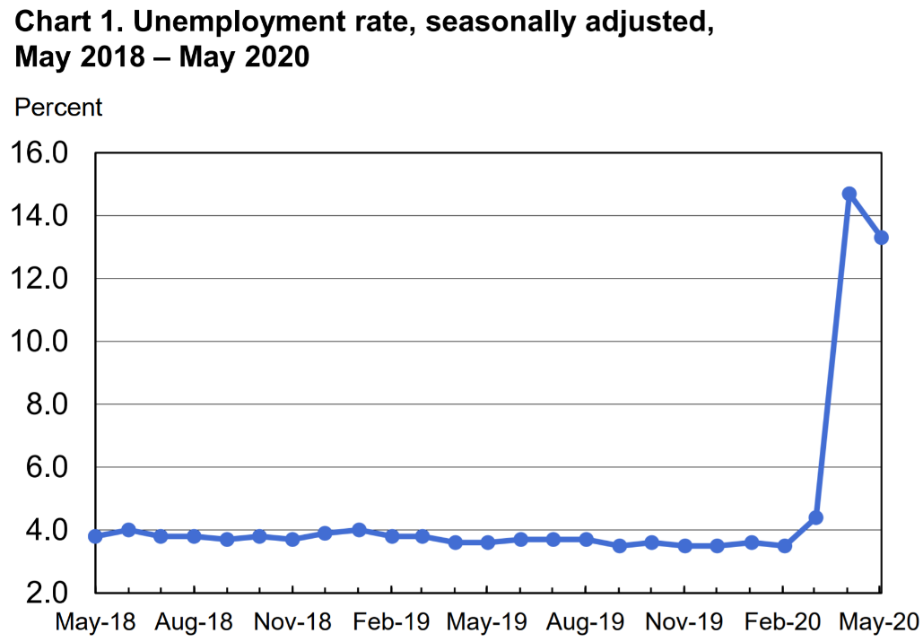

As governments around the world implemented lockdowns to avoid spread of covid-19, a disproportionate amount of damage to the economy has been done. More specifically, the service sector has been hit considerably, definitely greater than manufacturing. The global services Purchasing Managers’ Indices (PMI), meant to signal the strength of the direction in the services sector, went from a record low of 23.7 in April to 35.2 in May. These numbers imply a sharp decline, but the second figure is a signal of economic recovery, which appears to be growing at a steady rate. The services PMI for the United States increased from 26.7 in April to 37.5 in May. Although this figure does imply a recovery, a substantial part of the service sector will see negative social distancing consequences for the upcoming months. A full recovery is likely to occur near the end of the year, described as a ‘V’ shaped recovery.

In the second half of the year covid-19 cases could spike again, but given the future availability of treatments the damage will not reach current levels. Antibodies are targeted for the end of the year and a vaccine available in 2021.

Figures provided above may provide a general feeling for the state of the economy, but the global outlook is ***highly uncertain***. The figure below provides projected change in GDP for numerous countries in 2020. The high uncertainty relies in the fact where amid lifting restrictions see a rise in economic activity, an imminent second wave of covid-19 could result in a fallout in the path of economic recovery.

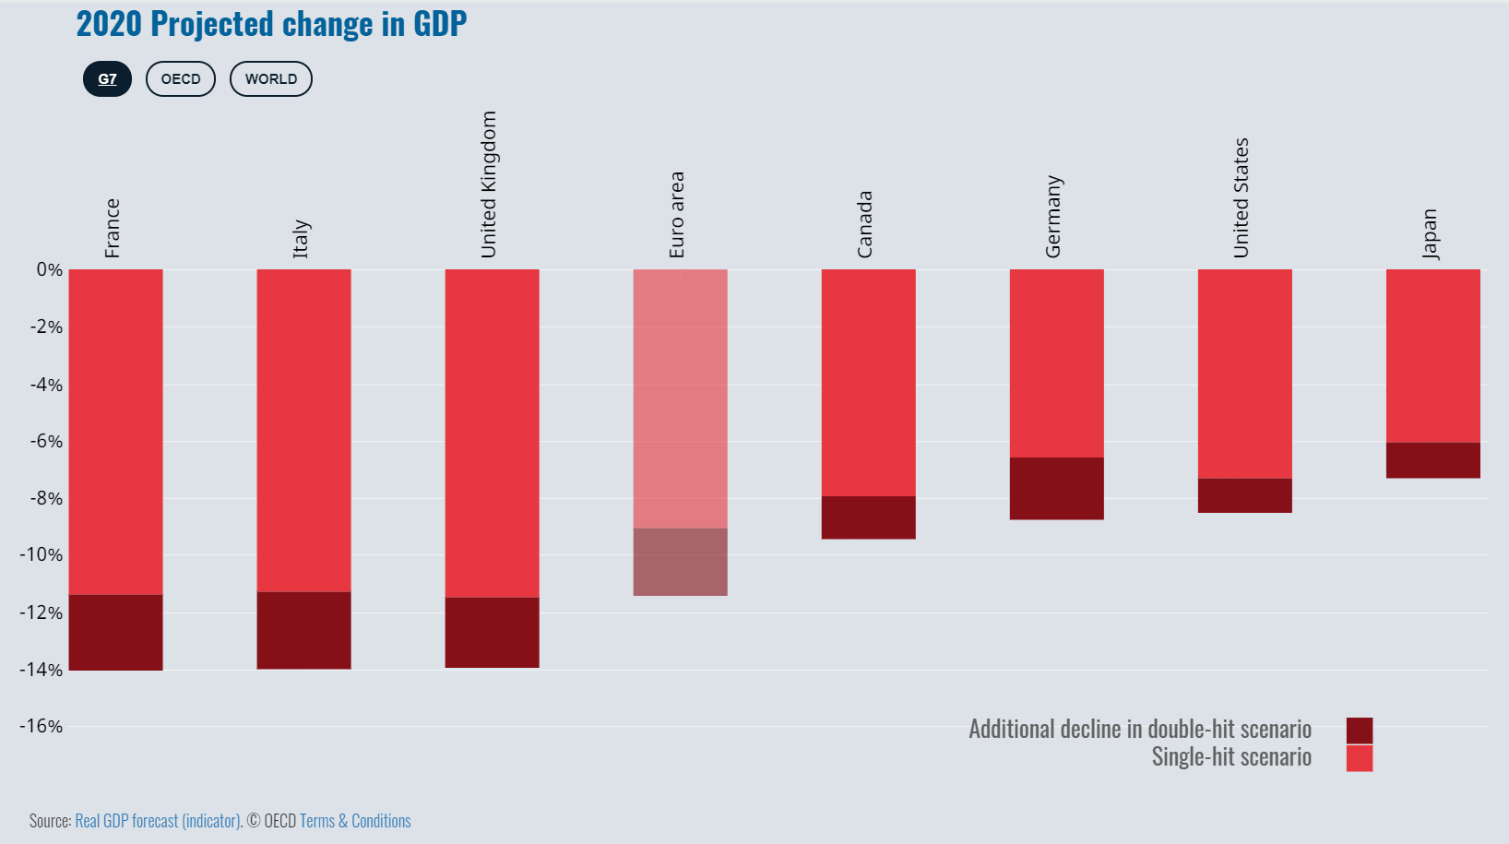

Data from OECD reveals that an economic recovery, with a second wave or not, may take up to two years. Of course, all of these estimates and projections should and must be taken with a grain of salt, but the message here is that the future is uncertain.

### Payments Industry Economic Conditions and Outlook

The coronavirus pandemic has impacted virtually every player in the payments industry. Trends such as contactless payments have been accelerated, and the way we shop is changing. Regardless of the social distancing efforts implemented over the past months, electronic payments still need to be made between businesses and individuals. This does not imply however that the payments industry will not be affected. E-Commerce: internet shopping continues to rise, as individuals purchase goods and services to ease the transition to isolation. Gig economy workers such as deliveries will be busier, and payment firms will be appointed to facilitate electronic payments. Regardless, consumer spending habits in this timeframe are unclear, although they are expected to decrease until social distancing restrictions are lifted and healthcare networks are prepared to ease of the damage of a possible second wave of covid-19.

P2P Payments: as the World Health Organization warns of the risks of handling and exchanging cash, electronic payment systems may see a rise as more and more people switch from physical cash. Optimistic projections assume that the change of these habits won’t last for only the period of isolation but be permanent for the long run. This means that firms in the payments industry may witness sharp declines in revenues for the short run (4-5 months, until regulations are lifted) but then have a long-run growth rate faster than those of the past years. Overall, about one-third, or **34 percent**, of adults under the age of 50 make **zero** purchases in a typical week using cash, compared with 23 percent of those ages 50 and older, **Pew Research Center** found. This number could get even lower as the use of cash during a global pandemic is lower than ever and stay as such for the long-run. Overall, the COVID-19 pandemic could contrive a further revolution in the switch to electronic payments.

Quarterly GDP in the second quarter of 2020 could decline by as much as 35 to 40 percent—and the payments industry’s financial outlook reflects that uncertainty in the short term. Source: **McKinsey**. Revenue growth for payment service is expected to turn negative for 2020, as much as 8% to 10%.

However, given the sudden switch from in-store payments (including electronic) to online payments, it offers more profitability to these payment companies as online transactions are more profitable. This is because they have a higher average processing fee to account for the higher risk.

# Section 2

## Company Analysis

*This section aims to provide a basic understanding of the underlying business model of each of the companies under analysis. The focus is to point out the similarities and differences among these companies which would enable this analysis to be comparable.*

### Executive Summary:

Visa, MasterCard, American Express and PayPal all work in the payments industry. They are all highly diversified and international. Over the past years these stocks have consistently outperformed the index given their extraordinary growth and growth potential.

It is important to grasp an understanding of what these companies do exactly in the payments industry and why they can be considered comparable. A summary is provided below, although further analysis for each company follows.

Visa and Mastercard act as intermediaries between issuers and acquirers, they control the flow of information. They don’t issue the credit cards to the cardholder, but rather to the issuers which then give them to the cardholders. American Express deals with a closed-loop network, acting as the issuer, acquirer and processor. It in fact issues credit cards directly to the cardholder. Brand loyalty is much higher for American Express than its competitors. It offers a unique experience with its loyalty and reward programs.

An online merchant would likely have a payments network to interact with Visa, Mastercard and American Express cards. This is where PayPal comes in. It acts as a processor/gateway connecting cards. But it is also a wallet, acting as an open loop system which holds people’s money via bank accounts.

An online shop uses PayPal’s gateway: if the user does not have a PayPal account but only a Visa/MasterCard/Amex card, it processes the transaction by communicating with the card’s network. However, if an online shop uses PayPal’s gateway and the user has a PayPal account with balance in it, it is used to pay directly the shop owner. No cards involved, so the potential fee of the transaction does not go to the issuer/acquirer and then to the credit card companies, but to PayPal alone.

There are many challenges credit card companies are facing, and the biggest is keeping up with innovation, which is expensive and a huge drain on resources. Regardless, the companies in question pour billions of dollars in an average deal, regularly. This trend does not appear to be slowing down and seems to be the main competitive advantage in this industry, as seen with PayPal.

### About *VISA*:

Visa is a global payments technology company, connecting consumers, businesses, financial institutions and governments in over 200 countries. It leads as the largest electronic payments network.

Visa serves a **two**-sided market with different players:

1. **Cardholders** are individuals that possess a Visa payment card.

**Issuers** are the financial institutions that issue Visa cards to the cardholders, extend credit to them, and determine the interest rates charged.

**Issuer processors** are third-party institutions with technology networks that manage transaction processing for issuers that do not have such technology.

1. **Merchants** are businesses that accept Visa cards as a payment mechanism.

**Acquirers** are the financial institutions that solicit merchants to accept Visa cards.

**Acquirer processors** are third-party institutions with technology networks that manage transaction processing for issuers that do not have such technology.

**The transaction process:**

The steps involved in a typical transaction are as follows:

1. The cardholder provides the card to the merchant. The merchant’s point of sale (pos) reads the account number and other information on the magnetic strip
2. The pos sends this information and amount of charge to acquirer or acquirer processor
3. The acquirer or acquirer processor combines the information into an authorization request
4. Visa identifies the proper card issuing bank and sends the authorization request to the issuer or issuer processor
5. The issuer or issuer processor receives the request and executes a number of safety tests. It then approves or denies the transaction and sends the authorization response to Visa
6. Visa routes the response to acquirer or acquirer processor
7. The acquirer or acquirer processor transmits the result of the authorization to the pos

For a 100$ transaction, the full amount is not delivered to the merchant. If the merchant discount fee is 2.4%, it receives 97.60$, the rest is split unevenly among the issuer and the acquirer, known as the interchange rate. The issuer gets to keep more of the merchant discount fee because of a higher risk of payment default from the cardholder.

Visa does **not** make money from a transaction. On the other hand, it earns revenues from the issuers and acquirers based on the overall payment volumes (total monetary value of transactions for goods and services) and number of transactions processed.

### About MasterCard:

Mastercard is an American multinational financial services corporation, leading with Visa the electronic payments network. It operates in over 250 countries, connecting merchants, consumers and financial institutions across the globe.

Its business model is highly comparable to that of Visa. In fact, the transaction process of the two is almost identical. MasterCard does not make money from transactions alone, but earns revenues from the overall payment volumes and number of transactions made.

While the two companies don’t extend or issue any cards, they do partner to offer the broadest array of products encompassing credit, debit, and prepaid card options. Both companies are at the forefront of competition and continue to innovate. They invest heavily in acquisitions of fintech companies and implement new service solutions constantly.

**Open-loop Network:** Visa and Mastercard operate a “transaction-centric” business model. This means that they earn revenue primarily on the payments volume and the transactions volume carried out through their cards. An open loop network is multi-party connecting issuers and acquirers, Visa and Mastercard then manage the flow of information between them.

### About American Express:

American Express American multinational financial services corporation which provides charge and credit payment card products and travel related services to individuals and businesses across the globe.

The business model of American Express is highly different to that of Visa and Mastercard. Firstly, its cardholders need to pay an annual fee to possess the card. This fee depends on the type of plan, although it starts at around 500$. The main difference is the **loop network**, which is **closed** rather than open. In such loop, payment services are provided directly to the cardholders and merchants by the owner of the network, American Express. It acts as both the issuer and acquirer. Revenue streams are generated from the merchant discount fees, it in fact focuses on achieving these streams by driving spending on its cards through reward programs for card owners. This further helps them earn more discount revenue from merchants. Hence, American Express model is “**spend**-centric” rather than “transaction-centric”.

Unlike Visa and Mastercard, which do not extend credit, American Express is heavily invested in the Consumer Finance Industry, which includes credit services and mortgage finance services. In fact, American Express offers existing eligible cardholders unsecured personal loans and business loans issued by American Express National Bank. The bank offers its personal loans in amounts from $3,500 to $40,000, with terms ranging from 12 to 48 months. Source: Credit Karma.

Its products and services also comprise merchant acquisition and processing, servicing and settlement, merchant financing, point-of-sale marketing, and information products and services for merchants; and fraud prevention services, as well as the design and operation of customer loyalty programs.

### About *PayPal*:

PayPal is a worldwide online payments system that supports online money transfers as an alternative to traditional paper checks and money orders.

PayPal’s business model is centered around processing customer transactions and earning money out of it. However, there are many subsidiary companies surrounding the PayPal ecosystem. These include Venmo, Xoom and Braintree. Such companies have different purposes and reach different consumers. For example, Venmo is focused on sharing money with friends, Xoom is rather on money transactions worldwide, and Braintree provides all tools online and mobile for businesses to accepts payments.

PayPal’s revenue can be split in two branches. The first one concerns transaction revenues and the transaction fees. These fees, unlike Visa and Mastercard, are charged directly to the merchant and consumers. The other branch deals with value added services, including fees and loans. Moreover, any money left over in a PayPal account is used to earn interest on loans and other services. Around 18% of e-commerce sales are estimated to be processed by PayPal.

The crucial difference between payments/transfers by using PayPal with respect to Visa/MasterCard/American Express is that PayPal provides electronic fund transfers between two accounts. It uses its own method which implies that no personal details are required to be sent to the other person. Hence there is no risk of the credit card number being stolen. With Visa/MasterCard/American Express the credit card details are sent to the other person. Overall, PayPal is more secure.

# Section 3

## Financial Reports Analysis

*This next section concerns the analysis of financial reports by interpreting various metrics, ratios and percentage growth of certain elements in order to draw a comparable analysis among these companies.*

### Executive Summary:

Apart from Amex, these companies have sustained a solid 8%-20% revenue growth yearly, giving insights of the strength of the payments industry but also the consistent growth that it is enduring. This is important to highlight to understand if the **sustainability** of such growth can be sustained for years to come. According to *McKinsey’s* payments map, it predicts a further 6% revenue growth across the entire industry until 2023. But these companies aren’t industry average, but rather industry leaders, so a revenue greater than 6% is realistic. What is to come in 2020 in unsure for revenue, but given the market dominance, increased credit card usage and further online shopping, it is likely that these **extraordinary** revenues will be sustained in the long-run. Moreover, there are areas of growth still untapped that could further boost revenues. For example, the potential for the card companies to take market share in areas such as payments between accounts by individuals, sending cash across borders, and in helping small businesses to pay their employees. Source: *Barrons*.

Lastly, the revenue stream for these companies is not limited exclusively to the US or other developed countries, but rather increasingly focused on emerging markets such as Latin America and Asia-Pacific. This means that potential for growth is enormous, not only in national territory but international. 2020 could be a bad year for these companies, but their significant drop in prices offer an opportunity to capitalize on pessimistic market sentiment. The perfect time to purchase is impossible to predict, but as of now the drop-in share prices does not reflect an 8% loss in revenues or even the growth potential in the long-run.

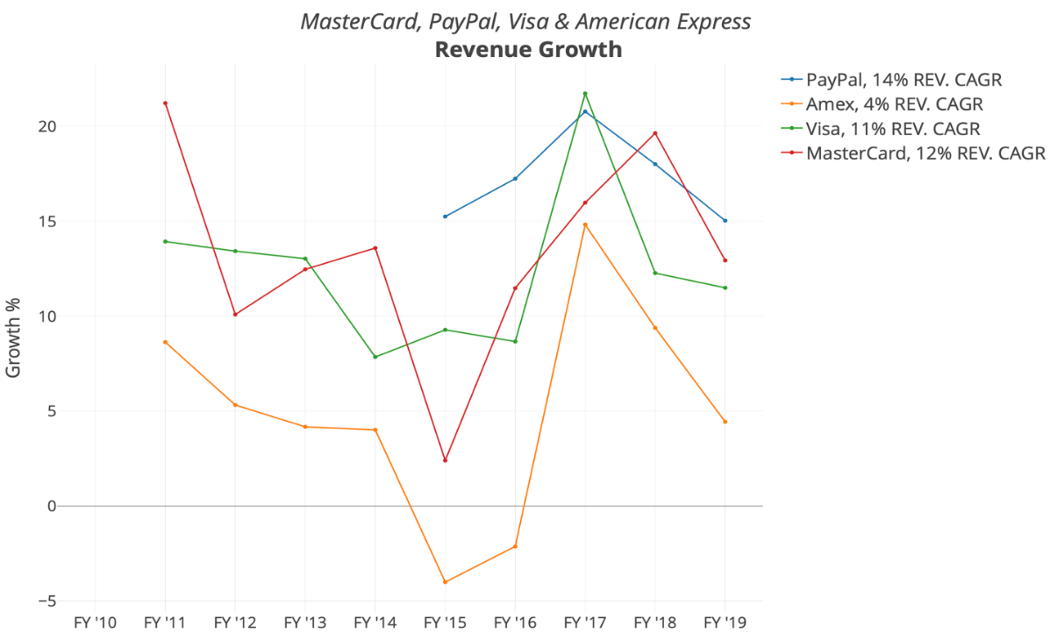

**

**

**

**

### Enterprise Value

Among these four companies, Visa is the most valuable, with an enterprise value of 390 billion dollars. Followed by MasterCard with a value of 276 billion dollars, PayPal with 140B$, and American Express at 149B$. Enterprise value is a valuable estimate when taking into account the full value of a company, meaning that not only does it include market capitalization, but also debt and cash. For this reason, debt to equity is extremely important to point out since it gives a good idea of the company’s liquidity and how it could be faced when revenue streams start to decrease and a recession (current one) hits. By observing these company’s balance sheets, the table below gives a good representation of this idea:



*Debt calculated as short term debt + long term debt*

Apart from American Express, these companies are jewels when it comes to debt. Visa reports an incredibly low debt to equity ratio of 0.72, MasterCard 1.42 and PayPal even lower at 0.29.This shows that in hard times as these ones, such companies will not face major issues. Amex however, reports a value of 2.79, which is much higher than comparable companies. The average debt to equity value in the S&P 500 is 1.1, and although it varies among industries, it appears as if Amex is above average. Note however that its business model is slightly different to that of the other companies in this analysis, mainly because it operates in consumer finance industry and thus may require further sources of leverage.

# Section 4

## Share Price Performance

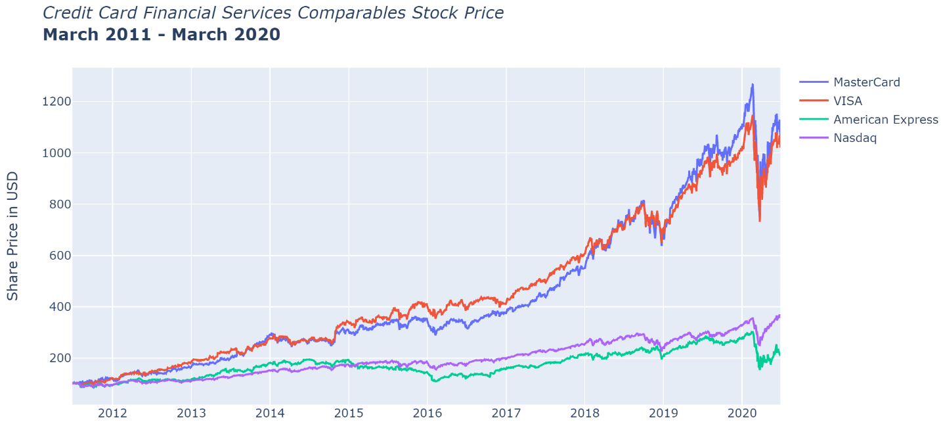

The chart above shows share price data for Visa, MasterCard, American Express and the Nasdaq Index from 2010-2020 March. A few movements stand out. The most notable is how badly Amex stock performed not only compared to its comps but the index itself. The table below shows this clearly. In a five-year period, it returned 29%, or 5.8% per year, while the Nasdaq Index 94.8% and 19% respectively. This is mainly due to its poor performance, particularly revenues, which stand at 3.5% six-year CAGR.

Another interesting movement is that of Visa and MasterCard. From 2010-2018, Visa’s stock was performing better than its rival. In 2018 the battle came closer as MasterCard was gaining speed. In fact, at the end of 2018, it published revenue growth of 20%, EBIDA growth of 25% and net income growth of 50%. Visa on the other hand, 12%, 11% and 54% respectively, clearly lower than its competitor. This was the turning point that led to MasterCard stock performing much better to that of Visa in the last year. As will be pointed out below, the net income growth is not sustainable as the increase was majorly led by the Tax Act of 2018, which lowered corporate taxes by 14%. So, if this market bull run was majorly led by the net income growth, then a few questions should be posed. Regardless, the market stays up to speed and when a company performs better than it is expected to, or performs better than its rivals, it is justified for its stock to jump as it did, even though the sustainability for the long run should be questioned.



Regarding the market collapse just witnessed, as of six months: American Express witnessed the greatest decline at 24.3%, MasterCard followed at -2.8%, while Visa +1% and PayPal an absurd +58%.

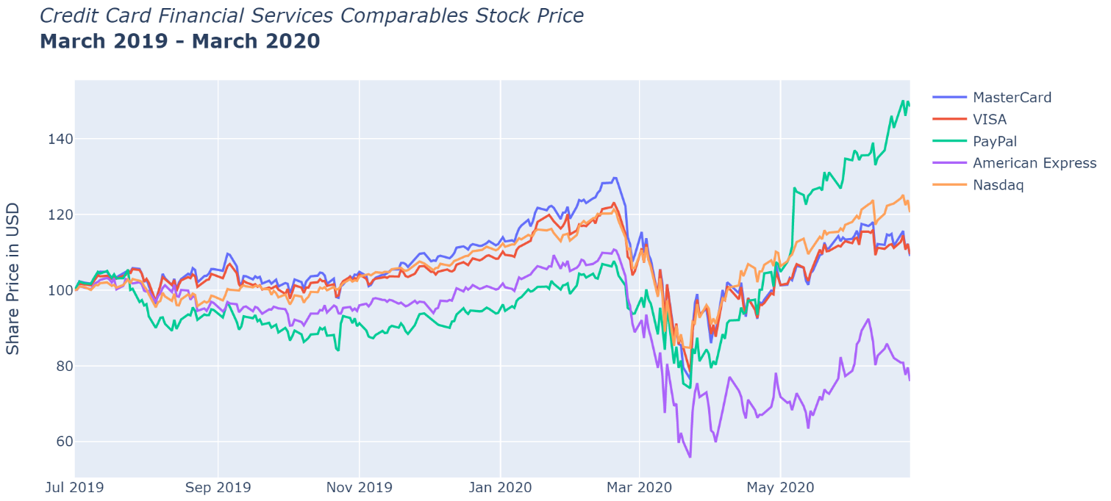

### Why Prices are at these Levels

Just a few months ago, these companies had their stocks plummet to very low prices, and all of a sudden, they have mostly recovered. This portion of the paper will try to explain why this has occurred.

First, Mastercard and Visa. An earlier version of this report forecasted that earnings would decrease by 8% in the payments sector in 2020, although this was not the case for these companies. For example, in Q1 of 2020 Visa net revenue was up 3%. Moreover, the market as a whole saw a rebound since economies started to reopen earlier than expected, unemployment figures were more optimistic and consumers began spending again. These factors led to share prices quickly rebounding across the entire stock market.

American Express has performed worse than its competitors given its business model. As described above, it is a spend-centric model, rather than transaction-centric like Visa and Mastercard. This means that as people spent less, Amex was hit far worst than other companies.

From the chart above, PayPal’s intense growth in stock price can be clearly seen. In just three months the stock gained 78.5%, an absurd figure to say the least. The reason for such growth can be explained by a surge in online shopping, and since PayPal manages a large portion of online transactions, the increase in share price has reflected it.

# Section 5

## Multiple Analysis

### Executive Summary:

Although these companies work in the same industry, they report different multiples, annual growth rates and other metrics. The most important thing is to understand why investors are willing to pay a certain price for these stocks. By looking at multiples alone conclusions may be derived since the industry is the same, but these aren’t very trustworthy since there are many other variables which could affect the price multiples. This section shows that a high multiple is justified by a high growth rate (EPS/EBITDA). It emerged from two regressions that Visa could be cheaper than MasterCard given that for the same growth rate, the price is higher.



The table above summarizes some of the most important ratios and metrics for the companies in this analysis. PayPal reports the highest P/E ratio at 51 and compound annual growth rates significantly higher than its comps. Visa and MasterCard have similar P/E ratios (32, 34) with also similar CAGRs and other metrics. Amex looks on the cheaper side with a P/E of 12 and very low annual growth rates. It does however have a higher cash conversion than its comparables.

### P/E Ratio to EPS growth rate – **Regression Analysis**



The chart above shows the relationship between the P/E Ratio and the compound annual growth rate of the EPS. Quite simply, it explains if a multiple can be explained and justified by an external factor. As shown, the correlation between these four data points is extremely strong, suggesting that these multiples make sense and are explained by financial data rather than just speculation or bullish momentum. In other words, a high P/E Ratio is justified by a high percentage increase of the EPS. For example, American Express has a very low P/E ratio of 11.5, and one might think of it as “cheap” given how low it is when compared to similar companies, but it is not cheap, it is correct. This is because Amex, over the course of 6 years has reported an annual increase in EPS of only 1.5%. Moreover, its revenue CAGR of 4.3% is miniscule when compared to PayPal’s 14.2%. In no way does this mean that American Express is worst, it simply means that if a share of it was to be purchased, its past performance (and future) would be discounted in its price. In fact, when compared to the P/E of PayPal, which stands at 50, it is reasonable since its EPS growth is of 34.3%.

Visa and Mastercard, which are very similar companies down to their business model, also have very similar metrics. However, Visa reports a P/E of 31.9 with an EPS CAGR of 14.2%, while MasterCard a P/E of 34.1 and an EPS CAGR of 14.4%.

The doubt is weather a P/E three points higher can be explained by a mere 0.2% higher EPS. By simply looking at these two data points, Visa is by all means cheaper than MasterCard. This is because for almost the same EPS growth you are paying a PE of 34.1 for MasterCard while a PE of 31.9 for Visa.

By looking at further data points below, it is evident that MasterCard stock is more expensive than Visa. This is because Visa showed a superior profit margin, higher revenue annual growth rate, almost identical EBITDA and net income annual growth rates except for a lower cash conversion.



However, when it comes to finance, timeframes are everything and depending on the way you pick data points, conclusions could be different. In fact, by looking at the CAGR for the 2017-19 timeframe, MasterCard outperforms Visa in every category. So perhaps the stock market already discounts these more recent statistics and thus values MasterCard higher than Visa. However, a three-year period such as in the data below may be volatile and the data inaccurate or even worst, unreliable. Also note that for 2015, MasterCard reported earnings 2% higher, and this may have been a once in a time, anomaly. To conclude this argument, depending on the time frame you choose, there may be different conclusion to weather MasterCard is more expensive than Visa.



Furthermore, depending on where the points rely, which is **above** or **below** the curve, conclusions could be reached as to weather a security is cheaper or more expensive. Firstly, it is evident that if all the points are on the curve, they are not cheaper nor pricier. This is because for a higher PE ratio you are discounting a higher EPS growth and vice versa. Secondly, assuming that the correlation is perfect: if a point relies under the curve it is more expensive. This is because for a lower EPS growth you are paying a higher P/E ratio. On the other hand, if a point is above the curve, it is technically cheaper as for an EPS growth above average, you are paying a price below average. This means that American Express and PayPal are cheaper, while Visa and MasterCard are more expensive. But it is evidently not as easy. There are many other assumptions that should be taken into account, such as various premiums investors are discounting when valuing the stock. Regardless, the market is semi-efficient and in times as these volatility and panic disrupts the true value of a security.

### EV/EBITDA Ratio to EBITDA growth rate – **Regression Analysis**

Another important correlation to observe is the EV/EBITDA Ratio to the EBITDA CAGR of the past 6 years. As shown below the correlation is very strong, with an R-squared of 0.98. The data implies that a high Enterprise Value to EBITDA can be supported by a high EBITDA growth.



Just as the P/E Ratio, the lower EV/EBITDA, the cheaper the valuation of the company. The average enterprise multiple in the S&P 500 is 14.9, and at first glance Visa, MasterCard and PayPal may seem expensive. However, the companies in this analysis focus in the payments industry which has a very high growth rate and thus a higher enterprise multiple. Moreover, as the correlation above shows, a high EV/EBITDA value is justified by a high EBIDA growth. American Express does have a very low multiple when compared to the other companies, which makes sense since its EBITDA CAGR is only 4.5%.

What is very interesting from this correlation is further proof the hypothesis formulated in the correlation above. It implied that Visa is cheaper than MasterCard given that for the same EPS growth, Visa’s PE ratio was lower by 2.2 points, which is high considering that these two companies are very similar. The data is as follows: Visa EV/EBITDA is 24.3, with an EBTIDA growth of 11%, while MasterCard EV/EBITDA is 27.1 for an EBITDA growth of 11.1%.

What emerges in this correlation is that Visa is cheaper than MasterCard. This is because for an almost identical EBIDA growth, (0.1% delta), you are paying an enterprise multiple 2.7 points higher for MasterCard.

Like the first correlation introduced, depending on where the points rely, conclusions can be reached as to weather a security is cheaper or more expensive. If a point relies under the curve it is more expensive. This is because for a lower EBITDA growth you are paying a higher enterprise multiple. On the other hand, if a point is above the curve, it is cheaper as for an EBITDA growth above average, you are paying an EV multiple below average. This means that all of the companies in question are priced correctly, except for Visa. According to these assumptions it is cheaper since it is above the curve. But since the r-coefficient is off by 0.05, this tiny difference could be the distance to the curve represented by Visa. So it does not represent facts from which a conclusion can be drawn, but rather lower degree of relationship between the companies under study.

In finance, valuations fail because of the model behind them, it may be subjective and the data could be ‘dirty’. But with these two correlations I would suggest a high validity for the conclusions reached. This is due mainly for **a)** the strength of the R-squared coefficient: 0.95 and 0.98 respectively; **b)** the method used to calculate the correlations (excel correlation function) was identical for both; **c)** the source of the information is of high quality, coming from the SEC and Yahoo! Finance.

# Section 6

## Multiple Analysis, over time

*This next section concerns the analysis of financial ratios by interpreting the movement of these over various time periods.*

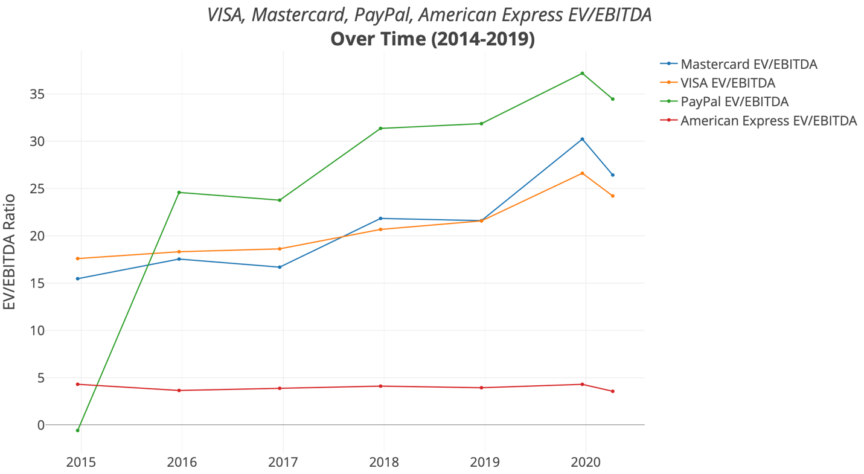

By observing the appendix on enterprise value over time, it is notable to note the massive spike in EV for Visa and Mastercard in the period 2018-2019, as it has almost doubled for both. This can be explained majorly by the increase in market capitalization in the same time frame, and not by increase in debt, cash and other EV components.

Regardless, the most sensible question now is what has caused such increase in share price, and thus market capitalization? A reasonable explanation can be found by observing the CAGR for different time frames and various income statement components.





Just by observing Visa and Mastercard for the period 2017-19, it is evident that net income has grown dramatically in this time frame. Amex also reports extraordinary net income CAGR but it was offset by its lower revenue growth. In fact, Visa, Mastercard and PayPal have produced above average revenue growth in this period (benchmark 6%). This has led to the subnormal increase in share price for Visa and MasterCard. Regardless, PayPal has not shown such considerable net income growth which can explain why its EV has grown at a lower rate.

This increase in net income can be explained by lower taxes being charged to these companies. The force behind this is the “*Tax and Jobs Act of 2017”*, where not only individual income tax was lowered, but corporate tax went from 35% to 21%. Earnings per Share ratio can explain this.

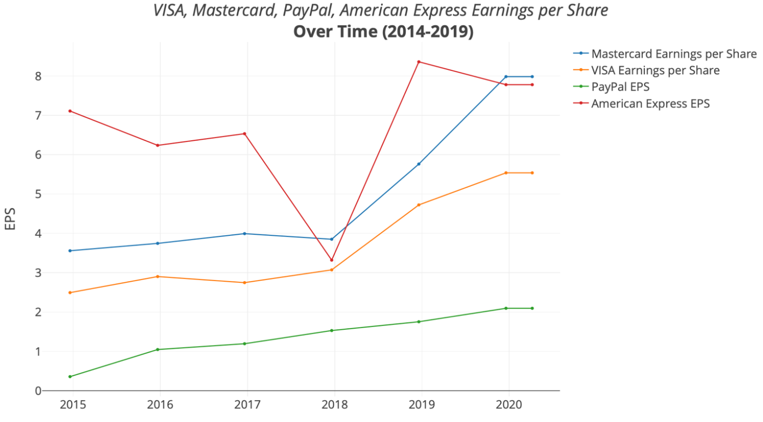

Since the tax act was implemented in companies’ income statements for the fiscal year ending 2018, by observing the chart above it is notable to see the EPS in 2018 jumped by 53% for Visa, 49% for MasterCard, only 14% for PayPal and an absurd 151% for American Express. Evidently, this led to a decrease in the Price – Earnings Ratio for all companies. This is shown below.

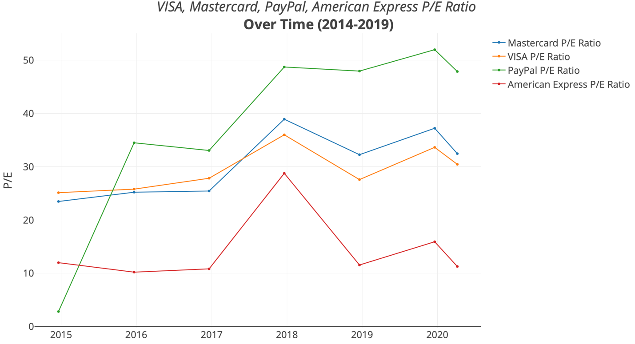



To reiterate, one of the major concerns when analysing these companies is understanding weather their growth is sustainable for the long term and weather past data can help reach reasonable conclusions. Just by observing the chart above, it is evident that we are currently experiencing levels well below of what they were 2 months ago. I do believe that until bullish momentum, the prices of these stocks were experiencing a bull run at a rate higher than what the company could achieve in that time-frame, regardless, their valuations were justifiable.

# Section 7

## Earnings Forecasting through Discounted Cash Flow Model

### Executive Summary

The Discounted Cash Flow model is a technique used to measure the intrinsic value of a company’s share price by discounting future cash flows under a set of assumptions. This part of the analysis focuses on keeping the methodology straightforward and not too complicated. Hence, for each of the four companies, the DCF approach is inherently the same. I have used the EV/EBITDA multiple to determine the company’s terminal value.





